Reflection
The following list details the last semester’s team successes. These accomplishments focus on team success from a project management and team communication standpoint
- Team practiced prompt communication concerning personal and school related issues, affecting team meetings.
- The team put in more than adequate time and effort into completing project tasks. The team kept an acceptable pace in project development, considering evolving project details.
- The team recorded accurate times spent regarding timecard assignments.
- The team delegates work well on team assignments and have no trouble when communicating a need for help.
- The team had no interpersonal conflicts at any time during the duration of the semester.

The following list details the shortcomings of the team last semester with regards to team communication and project management.
- The team needs improvement in completing most of our assignments earlier than the scheduled time for completion.
  - 1: Set preliminary individual deadlines for earlier than the assignment deadline to give extra time for editing and refining.
- The team needs improvement in more thorough note taking in meetings of any kind.
  - 2: The team will designate a note taker per every meeting to ensure completeness and quality of meeting summaries.
- The team needs to initiate project tasks given in staff meetings sooner than later, preferably right after the task has been assigned.
  - 3: The team’s delegated note taker will debrief the team immediately after a staff meeting so members can begin on assigned tasks as soon as possible.
- The team needs to stay in closer contact with the EE Sub-team.
  - 4: The team will engage in a weekly project status update with the EE Sub-team.
The following list details the remaining design efforts needed for project completion.
- Redesign of the current rear frame and electrical housing designs need to be finished.
- The gearbox design needs finalization depending on the EE Sub-team test results for the motor.
- The team needs a steering wheel design, as well as a seating design.
- Firewall material choice needs to be finalized.

Gantt Chart
The team’s updated Gantt chart, shown in the Appendix, shows the team’s working goals leading up to the first Hardware Status Update. Figure 1A shows short term goals that will contribute to the complete reassembly of the suspension system on Baja #44. This milestone will represent an approximate 33% completion in hardware assembly. Beginning with the first Hardware Status Update and working back towards the present, below is a list of tasks for the team to complete:

- Reassemble suspension system on #44
- Finish fabrication of FE control arm, rear knuckles, and spindles
- Order remaining materials/components for vehicle restoration
  - Steering kit
  - Bearings for rear knuckles

Purchasing Plan
Table 2: Items Purchased
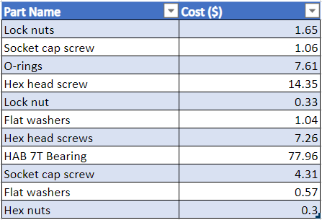
In table 2, it shows the parts that have already been purchased in Capstone I in the last semester. These parts are for the front end of the Baja vehicle. The plan for this semester for doing purchasing orders is:
- Talk to the Baja Team if having issues in finding certain parts
- Plan to purchase by January 18th
- Have backup vendors if item is not available through primary vendor
- Make sure parts are in stock

Manufacturing Plan
Table 3: Items to be manufactured
In table 3 above, the parts that will need to be manufactured, along with some related information, is detailed. The plan is not finalized, and specific areas of improvement are pointed out below.
- Paneling material needs to be finalized, as well as production details.
- Steering wheel design needs to be finalized for ease of manufacture.
- Material for battery casing and rear knuckles needs to be sourced.
- Gearbox design needs to be finalized and materials sourced.
- Mounting design needs to be finalized based on other part redesigns

Appendix
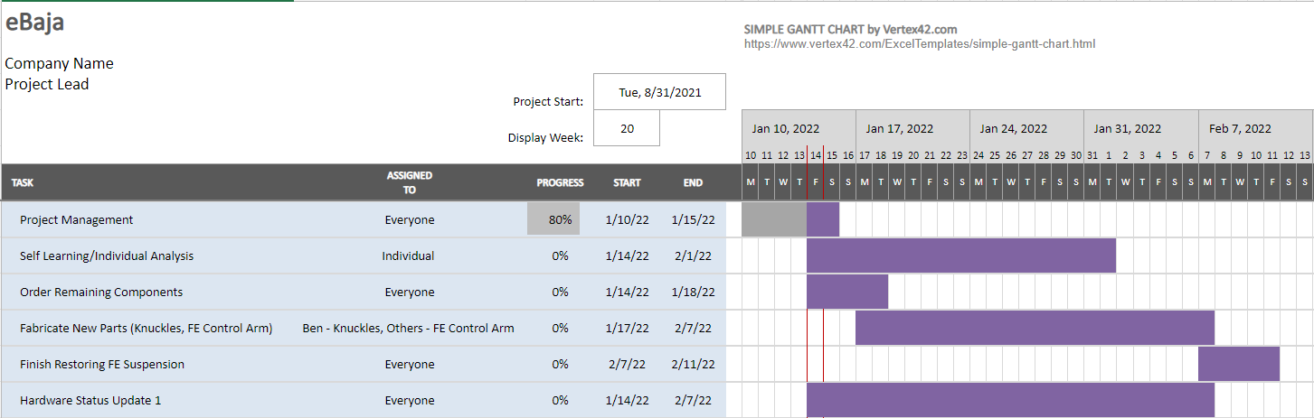Figure 1A: Updated Gantt Chart

